**QUICK INFORMATION FORM**

Photograph





1. **First Name:** _Akshaya____________________________________________
2. **Middle Name:** ___________________________________________
3. **Last Name:** _Balineni________________________________________

Xoriant Email Format: *First Name.Last* [*Name@Xoriant.com*](mailto:Name@Xoriant.com) *e.g.* [*Ajay.Singh@Xoriant.com*](mailto:Ajay.Singh@Xoriant.com)

1. **Your preferred Xoriant Email id:** _______akshaya.balineni@Xoriant.com________________
2. **Mobile Number: __**9154249468___ 5. **Landline Number:** _______________________
3. **Emergency Contact Information:**

Name: ____Balineni Praveen Kumar__________

Mobile Number: ____8008663932_________

Relationship with employee: _______Brother______

1. **Permanent Address:** House No : 1749, Backside Government High school, Indiramma colony, Piler, Chittoor Dist, Andhra Pradesh - 517214
2. **Temporary/ Local Address:** House No : 1749, Backside Government High school, Indiramma colony, Piler, Chittoor Dist, Andhra Pradesh - 517214
3. **Blood Group:** _______O +ve_______
4. **Date of Birth: (DD/MM/YYYY)** _____15/05/1999__________
5. **Pan Card No.** : _______EFNPA6699F_________
6. **Religion :** _________Hindu_________ (Optional)



1. Marital Status : Married Unmarried

**NOMINATION FORM**

**Employee Name:**

**Employee No.:**

**I declare the person mentioned below as my nominee to receive any legal dues towards me from the Xoriant Solutions Pvt. Ltd., in the event of my death or termination of services with the organization due to mental disorder / disability.**

**Name of the Nominee:** **__________Balineni Harinadh______________________________________________**

**Relation with employee: _____________Father___________________________________________**

**Date of Birth: 10/Apr/1967**

**Age: __57___Years \***

**Address of the Nominee:** House No : 1749, Backside Government High school, Indiramma colony, Piler, Chittoor Dist, Andhra Pradesh - 517214

* If the nominee is minor, I appoint Mr. / Ms. ________________________________________, Age:________,Address:________________________________________________________________

_________________________________________________________________________

to receive such dues on behalf of my nominee as mentioned above.

Any such due amount paid by Xoriant Solutions Pvt. Ltd. to the nominee will be deemed as the full discharge of the liability.

This nomination does not have relation with my Provident / Pension Fund account nomination, as I have already declared nominee in the PF forms while joining the company.

**Scanned Signature of the Employee:**

**Name: Balineni Akshaya**

**Date: 29 Oct 2021**

**Place: Piler**



**LIST OF DOCUMENTS**

**(Create a zip folder with all the below documents & send as a attachment)**

**Employee Name:**



1. **1 passport size photograph**
2. **Education:**

∙ SSC & HSC Mark sheets

∙ Mark sheets (All Semesters) and convocation certificates of degree/ post graduation.

* Additional Education Certificate and Make sheets if any (Eg. Diploma, NIIT, NCSt, MCSD, Novell Netware etc.)

1. **Employment:**

* Appointment letter, Experience and relieving certificates from ex- employer and last 2

month’s pay slip.

* Previous all ex-employer’s appointment letters, experience and relieving certificates and

last month’s pay slip.

1. **Passport:**

∙ All relevant pages. Include if any previous visa / Work Permit authorization and other documents.

**5)** **Marriage certificate**

1. **Pan Card &**
2. **Residential Proof (Lightbill/Rent Agreement)**
3. **Aadhar Card**

Please mention the reason, if any of the above documents are not given/ mailed.





***I hereby accept that all the above documents have been collected with my consent.***

Documents checked by: ____________ Date of Joining: ____________

HR Signature: ____________ Scanned Employee Signature: ____________

*Note: One Independent set of photocopies to be submitted for all above documents*



**EMPLOYEE ID CARD**





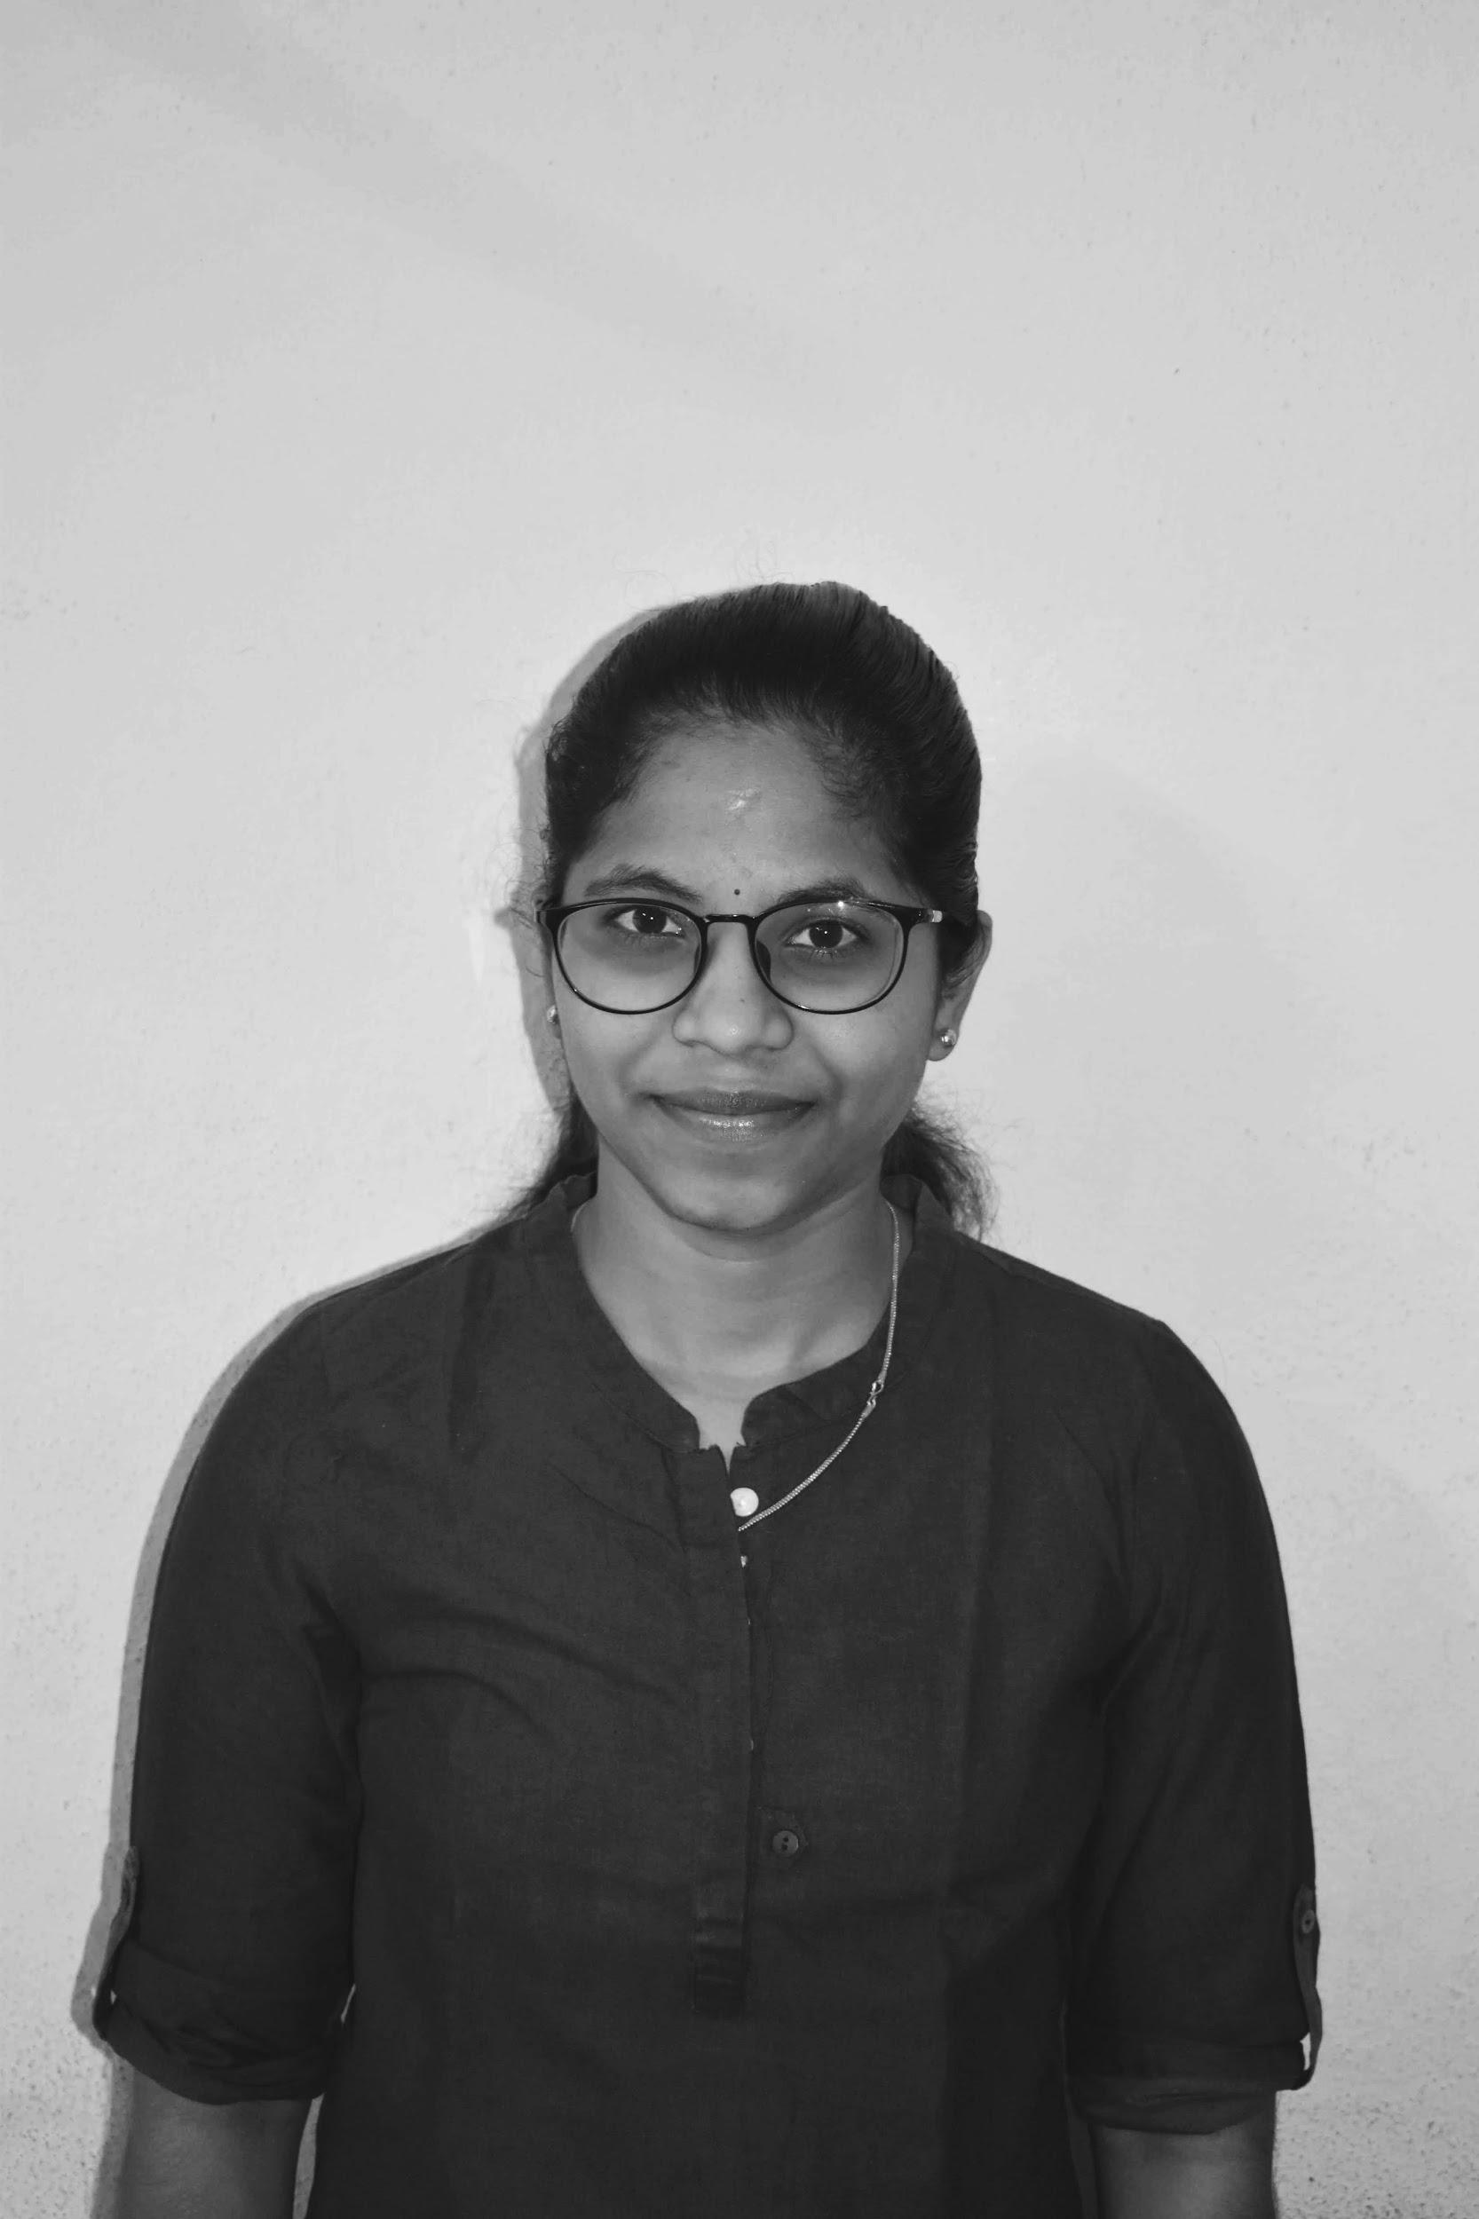

|  |  |  |  |
| --- | --- | --- | --- |
| **Employee Name** | **: -** | **Akshaya Balineni** | |
| **Employee Code** | **: -** | **__________________________________________** | |
| **Branch Name** | **: -** | **__Baner Pune___________________________** | |
|  |  |  |  |
| **Designation** | **: -** | **Associate Software Engineer** | |
| **D.O.J.** | **: -** | **29 Oct 2021** | |
| **Contact No.** | **: -** | **9154249468** | |
| **Emergency Contact No.: - +91 8008663932** | | | |
| **Blood Group** | **: -** | **O +ve** | |

